COMPUTING LAB - II
ADVANCED SYSTEM SOFTWARE LAB - CSE 5261
MTech - CSE
Week - 6

Name : Rajat Jain
Reg No : 200913010

Lab Exercises:

1) Write a Recursive Descent Parsing For C grammar.

Code

print("Recursive Descent Parsing For C grammar\n")
global s
program = input("Enter the program to be parsed\n")
s=list(program)
global i
i=0
def match(a):
global s
global i
if(i>=len(s)):
return False
j = "".join(s[i:i+len(a)])
if(j == a):
print(f"{j} == {a} , Matched")
i = i + len(a)
return True
else:
return False

def Program():
if(match("main(){")):
if(declarations()):
if(statement_list()):
if(declarations()):
if(match("}")):
return True
else:
return False
else:
return False
else:
return False
else:
return False
else:
return False

def declarations():
if(data_type()):
if(identifier_list()):
if(match(";")):
if(declarations()):
return True
else:
return False
else:
return False
else:
return False
else:
return True

def data_type():
if(match("int")):
return True
elif(match("char")):
return True
elif(match("float")):
return True
else:
return False

def identifier_list():
if(id()):
if(X()):
return True
else:
return False
else:
return False
def X():
if(match(",")):
if(identifier_list()):
return True
else:
return False
elif(match("[")):
if(number()):
if(match("]")):
if(Y()):
return True
else:
return False
else:
return False
else:
return False
else:
return True

def Y():
if(match(",")):
if(identifier_list()):
return True
else:
return False
else:
return True

def statement_list():
if(statement()):
if(statement_list()):
return True
else:
return False
else:
return True

def statement():
if(assign_stat()):
if(match(";")):
return True
else:
return False
elif(decision_stat()):
return True
elif(looping_stat()):
return True
else:
return False

def assign_stat():
if(id()):
if(match("=")):
if(expn()):
return True
else:
return False
else:
return False
else:
return False

def expn():
if(simple_expn()):
if(eprime()):
return True
else:
return False
else:
return False

def eprime():
if(relop()):
if(simple_expn()):
return True
else:
return False
else:
return True

def simple_expn():
if(term()):
if(seprime()):
return True
else:
return False
else:
return False

def seprime():
if(addop()):
if(term()):
if(seprime()):
return True
else:
return False
else:
return False
else:
return True

def term():
if(factor()):
if(tprime()):
return True
else:
return False
else:
return False

def tprime():
if(mulop()):
if(factor()):
if(tprime()):
return True
else:
return False
else:
return False
else:
return True

def factor():
if(id()):
return True
elif(number()):
return True
else:
return False
def decision_stat():
if(match("if(")):
if(expn()):
if(match("){")):
if(statement_list()):
if(match("}")):
if(dprime()):
return True
else:
return False
else:
return False
else:
return False
else:
return False
else:
return False
else:
return False

def dprime():
if(match("else{")):
if(statement_list()):
if(match("}")):
return True
else:
return False
else:
return False
else:
return True

def looping_stat():
if(match("while(")):
if(expn()):
if(match("){")):
if(statement_list()):
if(match("}")):
return True
else:
return False
else:
return False
else:
return False
else:
return False
elif(match("for(")):
if(assign_stat()):
if(match(";")):
if(expn()):
if(match(";")):
if(assign_stat()):
if(match("){")):
if(statement_list()):
if(match("}")):
return True
else:
return False
else:
return False
else:
return False
else:
return False
else:
return False
else:
return False
else:
return False
else:
return False
else:
return False

def relop():
if(match("==")):
return True
elif(match("!=")):
return True
elif(match(">")):
return True
elif(match("<")):
return True
else:
return False
def addop():
if(match("+")):
return True
elif(match("-")):
return True
else:
return False

def mulop():
if(match("*")):
return True
elif(match("/")):
return True
elif(match("%")):
return True
else:
False

def id():
if(match('a')):
return True
elif(match('b')):
return True
elif(match('c')):
return True
elif(match('d')):
return True
elif(match('e')):
return True
elif(match('j')):
return True
else:
return False

def number():
if(match('0')):
return True
elif(match('1')):
return True
elif(match('2')):
return True
elif(match('3')):
return True
elif(match('4')):
return True
elif(match('5')):
return True
elif(match('6')):
return True
elif(match('7')):
return True
elif(match('8')):
return True
elif(match('9')):
return True
else:
return False

if(Program()):
if(i == len(s)):
print("Accepted")
else:
print("Not Accepted")
else:
print("Not Accepted")

Output

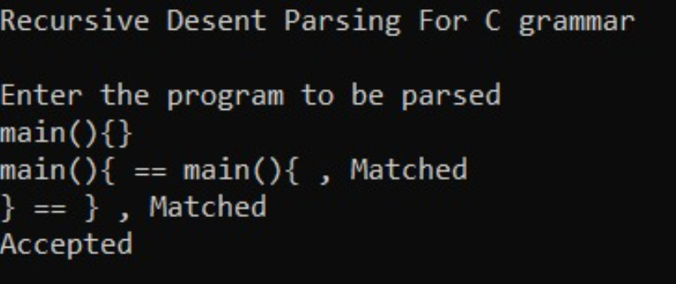

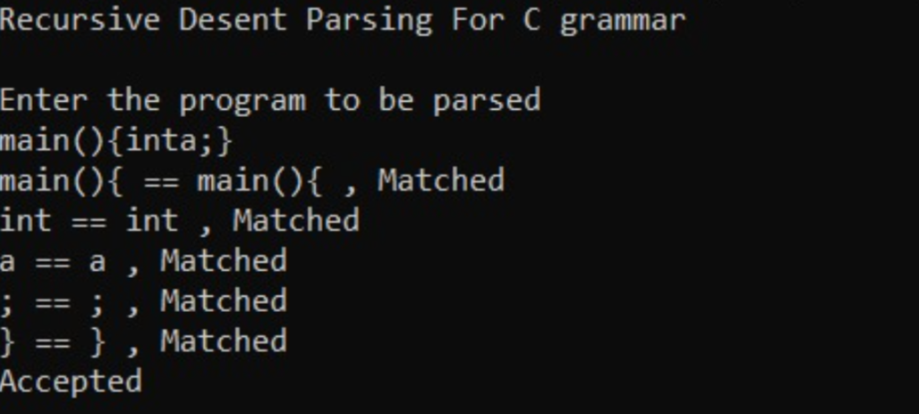

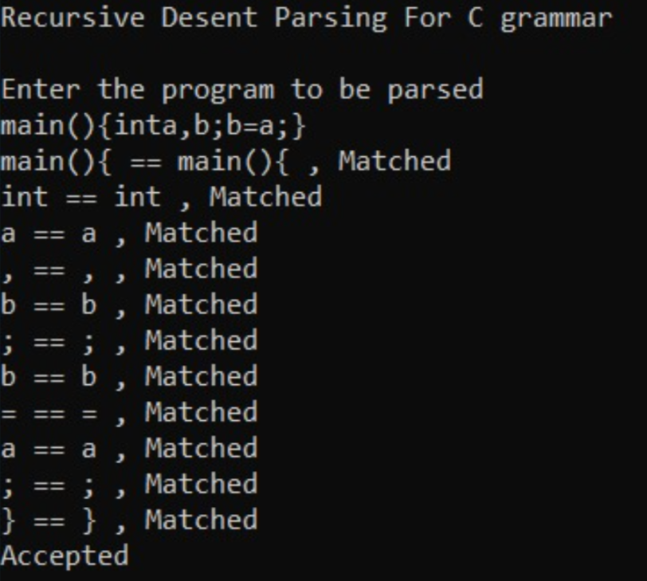

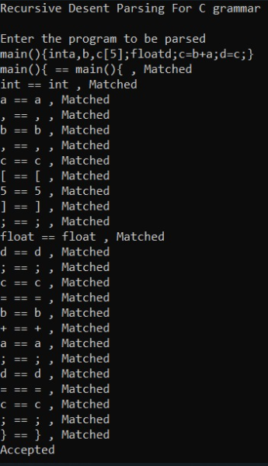

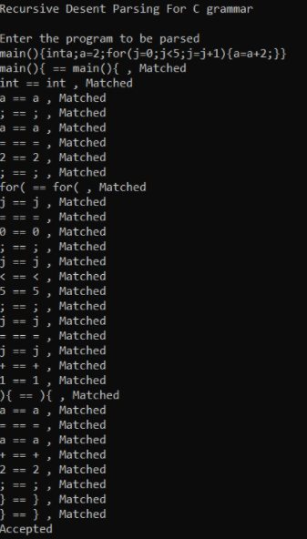

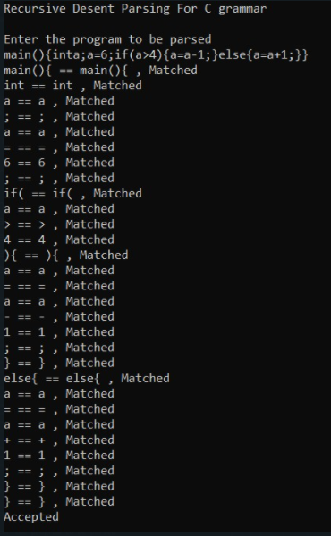

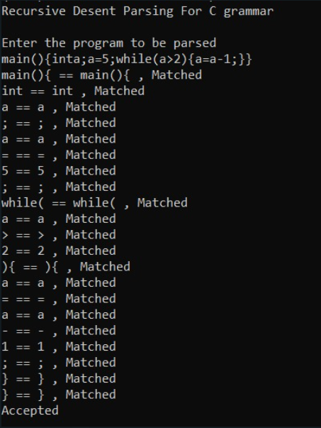

2. Write a python program to generate tokens for the perl script given below.

#! /usr/bin/perl
#get total number of arguments passed.
$n = scalar (@_);
$sum = 0;
foreach $item(@_) {
$sum += $item;
} $
average =
$
sum +
$
n;
#! Represents path which has to be ignored.
# followed by any character other than ! represents comments.
$n followed by any identifier should be treated as a single token.
Scalar, foeach are considered as keywords.
@_, += are treated as single tokens.
Remaining symbols are tokenized accordingly.

Code

from ply import lex
import re

tokens = [
# Literals (identifier, integer constant, float constant, string constant, char const)
'ID', 'TYPEID', 'INTEGER', 'FLOAT', 'STRING', 'CHARACTER','COMMENT',

# Operators (+,-,*,/,%,|,&,~,^,<<,>>, ||, &&, !, <, <=, >, >=, ==, !=)
'PLUS', 'MINUS', 'TIMES', 'DIVIDE', 'MODULO',
'OR', 'AND', 'NOT', 'XOR', 'LSHIFT', 'RSHIFT',
'LOR', 'LAND', 'LNOT',
'LT', 'LE', 'GT', 'GE', 'EQ', 'NE',

# Assignment (=, *=, /=, %=, +=, -=, <<=, >>=, &=, ^=, |=)
'EQUALS', 'TIMESEQUAL', 'DIVEQUAL', 'MODEQUAL', 'PLUSEQUAL', 'MINUSEQUAL',
'LSHIFTEQUAL','RSHIFTEQUAL', 'ANDEQUAL', 'XOREQUAL', 'OREQUAL',

# Increment/decrement (++,--)
'INCREMENT', 'DECREMENT',

# Structure dereference (->)
'ARROW',

# Ternary operator (?)
'TERNARY',

# Delimeters ( ) [ ] { } , . ; :
'LPAREN', 'RPAREN',
'LBRACKET', 'RBRACKET',
'LBRACE', 'RBRACE',
'COMMA', 'PERIOD', 'SEMI', 'COLON',

# Ellipsis (...)
'ELLIPSIS',

# Keywords
'KEYWORD',

# Parameter Array
'PARAMETERARRAY',

# Addition Assignment Operator
'ADDITIONASSIGNMENT'
]

# Operators
t_PLUS = r'\+'
t_MINUS = r'-'
t_TIMES = r'\*'
t_DIVIDE = r'/'
t_MODULO = r'%'
t_OR = r'\|'
t_AND = r'&'
t_NOT = r'~'
t_XOR = r'\^'
t_LSHIFT = r'<<'
t_RSHIFT = r'>>'
t_LOR = r'\|\|'
t_LAND = r'&&'
t_LNOT = r'!'
t_LT = r'<'
t_GT = r'>'
t_LE = r'<='
t_GE = r'>='
t_EQ = r'=='
t_NE = r'!='

# Assignment operators

t_EQUALS = r'='
t_TIMESEQUAL = r'\*='
t_DIVEQUAL = r'/='
t_MODEQUAL = r'%='
t_PLUSEQUAL = r'\+='
t_MINUSEQUAL = r'-='
t_LSHIFTEQUAL = r'<<='
t_RSHIFTEQUAL = r'>>='
t_ANDEQUAL = r'&='
t_OREQUAL = r'\|='
t_XOREQUAL = r'\^='

# Increment/decrement
t_INCREMENT = r'\+\+'
t_DECREMENT = r'--'

# ->
t_ARROW = r'->'

# ?
t_TERNARY = r'\?'

# Delimeters
t_LPAREN = r'\('
t_RPAREN = r'\)'
t_LBRACKET = r'\['
t_RBRACKET = r'\]'
t_LBRACE = r'\{'
t_RBRACE = r'\}'
t_COMMA = r','
#t_PERIOD = r'\.'
t_SEMI = r';'
t_COLON = r':'
t_ELLIPSIS = r'\.\.\.'

# Identifiers
t_ID = r'\$[A-Za-z_][A-Za-z0-9_]*'

# Integer literal
t_INTEGER = r'\d+([uU]|[lL]|[uU][lL]|[lL][uU])?'

# Floating literal
t_FLOAT = r'((\d+)(\.\d+)(e(\+|-)?(\d+))? | (\d+)e(\+|-)?(\d+))([lL]|[fF])?'

# String literal
t_STRING = r'\"([^\\\n]|(\\.))*?\"'

# Character constant 'c' or L'c'
t_CHARACTER = r'(L)?\'([^\\\n]|(\\.))*?\''

key_words = ['scalar','foreach']

t_KEYWORD = r'|'.join(key_words)

t_COMMENT = r'\#.*'

#Parameter Array and Addition Assignment

t_PARAMETERARRAY = r'@_'
t_ADDITIONASSIGNMENT = r'\+='

# Compute column.
# input is the input text string
# token is a token instance
def find_column(input, token):
line_start = input.rfind('\n', 0, token.lexpos) + 1
return (token.lexpos - line_start) + 1

def t_newline(t):
r'\n+'
t.lexer.lineno += len(t.value)

t_ignore = ' \t'

def t_error(t):
print(f"Illegal character {t.value[0]}")
t.lexer.skip(1)

lex.lex()

lines = []
with open('perlprog.pl','r') as file:
for line in file:
if not line.startswith('#!'):
lines.append(line)

data = ''.join(lines)

print(data)

generated_tokens = []

lex.input(data)
#Tokenize
while 1:
tok = lex.token()
if not tok: break
print(tok)
print(f"Column : {find_column(data,tok)} Row : {tok.lineno} Type : {tok.type} Value : {tok.value}")
token = f'<{tok.lineno},{find_column(data,tok)},{tok.value},{tok.type}>'
generated_tokens.append(token)
output = '\n'.join(generated_tokens)
print(output)
with open('output.txt','w') as file:
file.write(output)
file.write(f'\nTotal number of tokens generated = {len(generated_tokens)}')

Input

#! /usr/bin/perl
#get total number of arguments passed.
$n = scalar(@_);
$sum = 0;
foreach $item(@_) {
$sum += $item;
}
$average = $sum + $n;

Output

